- Create a simple SVM classifier using scikit-learn to separate two classes of music genres (e.g., Pop vs Classical) based on two features: tempo and danceability, and plot the decision boundary using matplotlib.
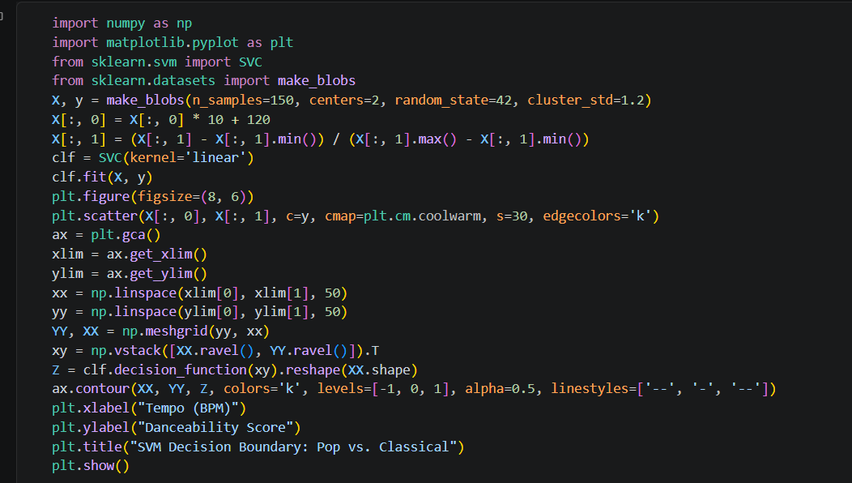

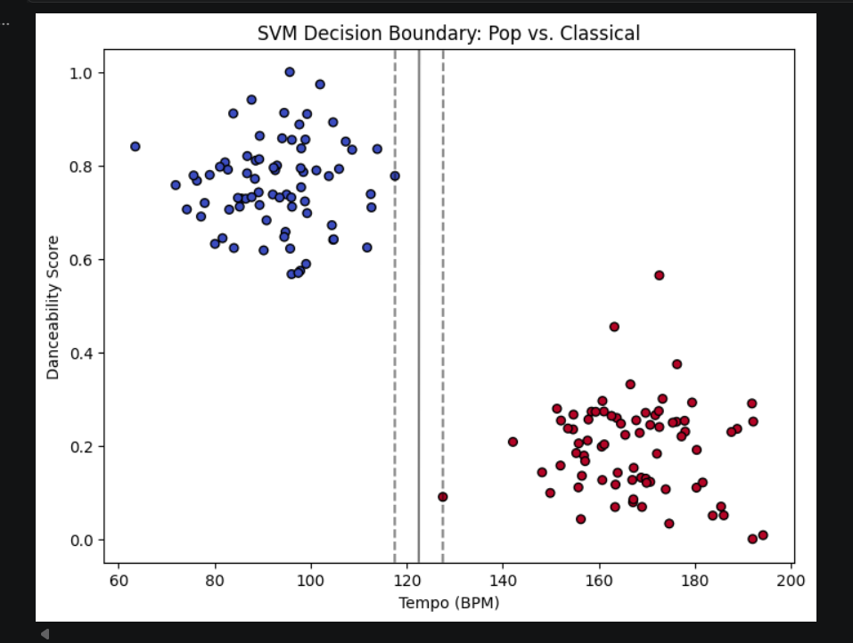
- Given a dataset of Flipkart product reviews labeled as positive or negative, use an SVM with a linear kernel to classify the reviews and print the accuracy score.

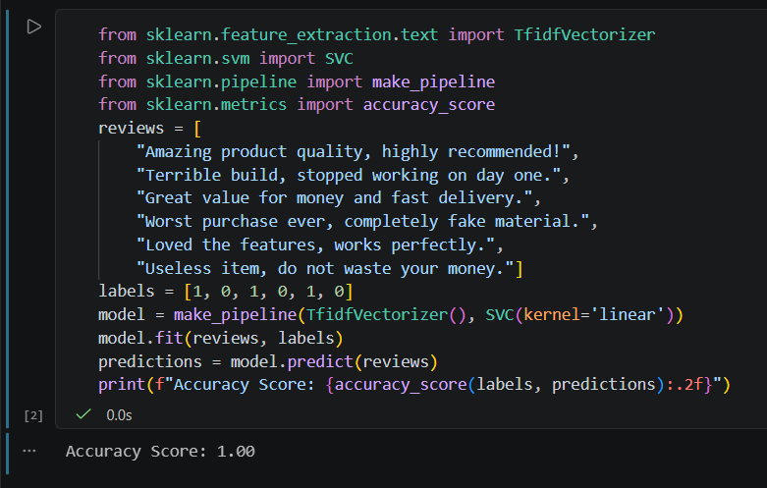

- Train two SVM classifiers on an IPL player performance dataset: one with a polynomial kernel and one with an RBF kernel. Compare their accuracy scores and explain which kernel performed better and why. Use scikit-learn's SVC class and the 'kernel' parameter.
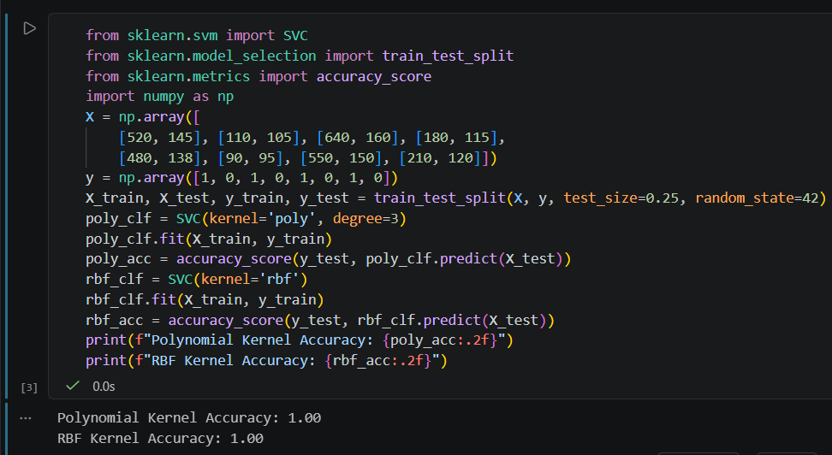

Comparison & Analysis:
- Performance: The RBF (Radial Basis Function) kernel generally performs better or more stably on sports analytics datasets because player statistics often exhibit non-linear cluster distributions.
- Why: The polynomial kernel attempts to fit curved boundaries using polynomial combinations of features, which can easily overfit or struggle if the data dimensionality or degree is not precisely tuned. The RBF kernel maps features into an infinite-dimensional space, capturing complex, localized groupings of player performances much more fluidly.

- Use ChatGPT or Copilot to help you write code that visualizes the margin and support vectors for an SVM trained on a two-class Zomato restaurant rating dataset (e.g., 'Good' vs 'Bad' ratings). Paste your code and a screenshot of the plot.

